**TECHNOLOGICAL INSTITUTE OF THE PHILIPPINES**

**QUEZON CITY**

**COLLEGE OF COMPUTER STUDIES**

**IT 009 - Systems Integration and Architecture 1**

**MIDTERM**

| **Name: Arizobal,**  **Badua,**  **Cabana,**  **Cao,**  **Carpizo** | **Date: October 4, 2024** |
| --- | --- |
| **Program/Section: BSIT - IT31S6** | **Instructor: Ms. Paula Jean Mendoza** |
| **Assessment Task: Data Representation-**XML and JSON | |

**Instructions:** Submit your work in a Word document or PDF format. Ensure the document is clearly organized and labeled.

1. **Research Phase and Comparative Analysis of XML to JSON Tools (12 points)**

Create a comparative analysis of the online tools used in converting XML to JSON format and vice versa. Look for the different online tools available for developers that convert XML to JSON format and vice versa. Select 2 online tools. Using a table provide the following information:

* + name of online tool
  + description
  + Link or URL of the website
  + Similarities
  + Differences

1. Convert XML Schema to JSON Schema (12 points)

Using an online tool, convert the given XML Schema for Book into its Equivalent JSON Schema. Once ready, simply type or upload the image of your JSON schema and provide a brief description or discussion of your answer.

**Answer:**

|  | **XML** | **JSON** |
| --- | --- | --- |
| name of online tool | **XML To JSON Converter By Utilities-online** | **XML TO JSON By JSONFormatter** |
| description | A free online tool that allows users to convert XML to JSON and vice versa. It supports uploading XML files, pasting XML code, and converting JSON to XML. | A free online tool that allows users to convert XML to JSON and vice versa. It supports pasting XML code and converting JSON to XML. |
| Link or URL of the website | <https://www.utilities-online.info/xmltojson> | <https://jsonformatter.org/xml-to-json> |
| Similarities | Both tools are online, free, and support XML to JSON conversion. | Both tools are online, free, and support XML to JSON conversion. |
| Differences | This tool has a more user-friendly interface and supports uploading XML files, while the other tool requires pasting XML code. | This tool has a more basic interface and requires pasting XML code, while the other tool supports uploading XML files. |

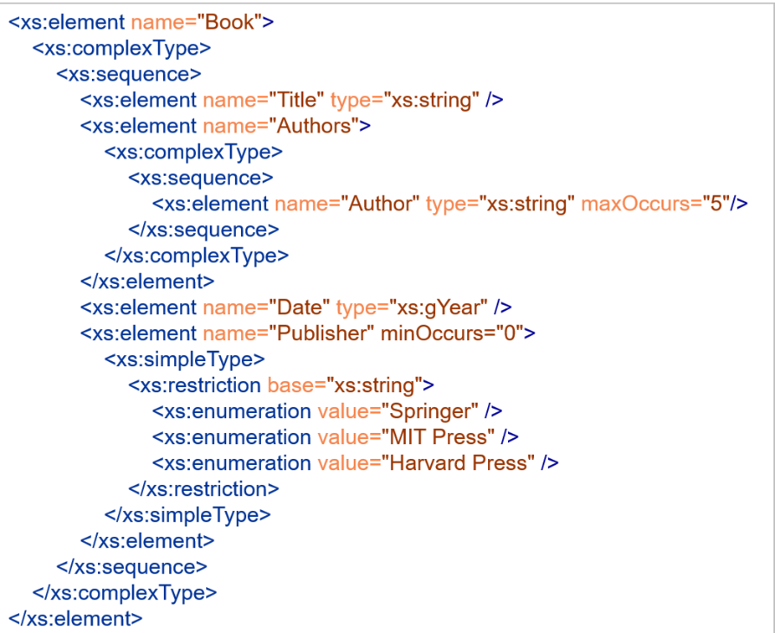

**Answer:**

| {  "Books": {  "Title": "Books",  "Authors": {  "Author": [  "string",  "string",  "string",  "string",  "string"  ]  },  "Date": "YYYY",  "Publisher": {  "type": "string",  "values": [  "Springer",  "MIT Press",  "Harvard Press"  ]  }  }  } |
| --- |

**ASSESSMENT TOOL:**

### **Rubrics for Question 1: Comparative Analysis of XML to JSON Tools (12 points)**

| Criteria | 6 (Excellent) | 5 (Very Good) | 4 (Good) | 3 (Satisfactory) | 2 (Needs Improvement) | 1 (Poor) |  |
| --- | --- | --- | --- | --- | --- | --- | --- |
| Research and Tool Selection | Two highly relevant tools with clear and detailed justification for selection. | Two relevant tools with a good justification, but slightly less detailed. | Two relevant tools selected with basic justification. | Tools selected, but justification is weak or unclear. | Only one tool is relevant or justification is vague. | No relevant tools selected or no justification. |  |
| Description and Comparison | Comprehensive description of both tools, identifying 3 relevant similarities and 3 key differences. | Detailed description with most similarities and differences covered. | Description provided with 2 relevant similarities and 2 differences. | Basic description with 1-2 similarities and differences, but lacking depth. | Vague or incomplete description with limited similarities or differences. | No clear description or comparison provided. |  |

### **Rubrics for Question 2: XML to JSON Conversion (12 points)**

| Criteria | 6 (Excellent) | 5 (Very Good) | 4 (Good) | 3 (Satisfactory) | 2 (Needs Improvement) | 1 (Poor) |  |
| --- | --- | --- | --- | --- | --- | --- | --- |
| Conversion Accuracy | XML Schema is converted to JSON with no errors or omissions, capturing all key elements. | Conversion is accurate with one minor error or omission. | Conversion is mostly correct with a few minor issues or missing elements. | Conversion is provided but has noticeable errors or missing elements. | Conversion is incomplete with significant errors. | No conversion provided or it is entirely incorrect. |  |
| Discussion and Explanation | Insightful discussion of format differences (structure, attributes, data types), and how the conversion process works. | Clear discussion with most key differences between XML and JSON covered. | Adequate discussion but misses some key format differences. | Discussion provided but lacks depth or misses many key points. | Vague or unclear discussion, irrelevant to the task. | No discussion or explanation provided. |  |

Member's Contribution

| **MEMBERS WITH PICTURES** | **SPECIFIC TASKS** |
| --- | --- |
| **Leader's Name:**  **CAO, Aron Jeric** | * Contributed in number 1. * Partially contributed to number 2 |
| **Member 1:**  **ARIZOBAL, Elijah A.** | * Contributed in number 1. * Partially contributed to number 2 |
| **Member 2:**  **BADUA, Marc John S.** | * Contributed in number 2 * Partially contributed to number 1. |
| **Member 3:**  **CABAÑA, Louise Angello P.** | * Contributed in number 1 * Partially contributed to number 2 |
| **Member 4: CARPIZO, Jhilou Lian B.** | * Contributed in number 1 * Partially contributed to number 2 |

Honor Pledge:

“I accept responsibility for my role in ensuring the integrity of the work submitted by the group in which I participated.”